**Project Description**

Studying abroad can be both exciting and difficult. But what might be contributing to this? One Japanese international university decided to find out!

Use your data manipulation skills to explore the data from a study on the mental health of international students, and find out which factors may have the greatest impact.

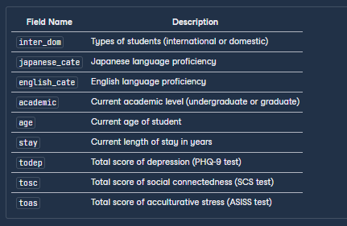

**Project Instructions**

Explore and analyze the students data to see how the length of stay (stay) impacts the average mental health diagnostic scores of the **international** students present in the study.

* Return a table with **nine** rows and **five** columns.
* The five columns should be aliased as: stay, count_int, average_phq, average_scs, and average_as, **in that order**.
* The average columns should contain the average of the todep (PHQ-9 test), tosc (SCS test), and toas (ASISS test) columns for each length of stay, **rounded to two decimal places**.
* The count_int column should be the number of international students for each length of stay.
* Sort the results by the length of stay in **descending order**.

**Query:**  
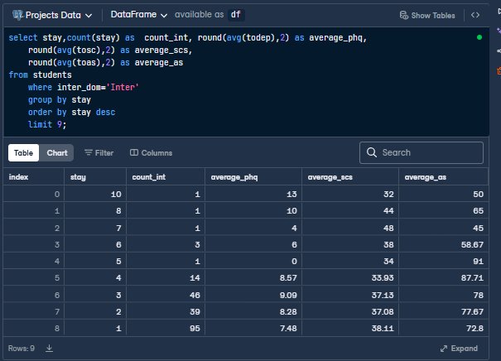

**That a an unormalized table and unable to share.**

so here is the full project details:

https://www.datacamp.com/datalab/w/e1aacdc7-69ab-4ced-9cdc-83bbbd03b341/edit?emitCellOutputs=false&reducedMenuBar=true&showExploreMore=false&showLeftNavigation=false&showNavBar=false&showPublicationButton=false&showOnlyRelevantSampleIntegrationIds[]=89e17161-a224-4a8a-846b-0adc0fe7a4b1&showOnlyRelevantSampleIntegrationIds[]=e0c96696-ae0a-46fb-b6f9-1a43eb428ecb&showOnlyRelevantSampleIntegrationIds[]=b1fcb109-b4fe-4543-bc98-681df8c4dc6e&showOnlyRelevantSampleIntegrationIds[]=fcf37a0e-f8bd-4c85-95a5-201d3eebea48&showOnlyRelevantSampleIntegrationIds[]=db697c09-0402-4a02-b327-26018dc2ecce&showOnlyRelevantSampleIntegrationIds[]=7569175e-98be-4c89-9873-c20f699a9cc7&fetchUnlistedSampleIntegrationIds[]=7569175e-98be-4c89-9873-c20f699a9cc7#a60a4d75-634c-4965-8e01-804780e6df98